This package contains the Matlab codes implementing the ScSPM algorithm described in CVPR'09 paper "Linear Spatial Pyramid Matching using Sparse Coding for Image Classification".

Their algorithm is composed of the following parts:

1. SIFT descriptor extraction.
2. Sparse coding. They integrated Honglak Lee's matlab codes for training the dictionary. They also provide a codebook trained on Caltech 101 for reference.
3. Multi-scale spatial max pooling of sparse codes.

Combining sparse coding with spatial max pooling, the algorithm leads to state-of-the-art performance on Caltech 101 based on SIFT descriptor. The most encouraging part of this algorithm is that the extracted feature favors linear model, and thus can be easily scaled up to large scale dataset.

function [ output_args ] = generateSparsefeature(img_dir, sub_dir, sift_dir, pooling_dir)

**Function**: Generate sift feature and sparse-coding features;

**Input**:

% Input: img_dir --- directory of image dataset;

% sub_dir --- if true: images are categoried into different

% folders; if false: images are stored together into a folder;

% sift_dir --- directory to store the generated sift feature;

% pooling_dir --- directory to store the generated sparse coding

% feature;

**Output:**

% sift_dir --- directory to store the generated sift feature;

% pooling_dir --- directory to store the generated sparse coding

% feature;

**Demo_1:**

**Command input:**



**Output:**

Sift features are stored in the directory of **.\siftfeature1.**

Sparse-coding features are stored in the directory of **.\siftpooling1**.

**Demo_2:**

**Command input:**



**Output:**

Sift features are stored in the directory of **.\siftfeature2** without sub-directory.

Sparse-coding features are stored in the directory of **.\siftpooling2** without sub-directory.

**Output illustration:**

1. Sift feature: (An example)

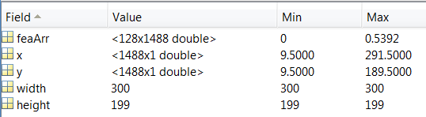

**feaArr**: sift features.

**x**,**y**: locations of sift key points.

**width**, **height**: image size after resize.

1. Sparse-coding features: (An example)



**sc_fea**: A 21504-D vector represents sparse-coding features. The image are divided into 1/4/16 parts. Then for each part, a 1024-D feature are obtained. Therefore, 21504 = (1 + 4 + 16) * 1024. 1024 is the codebook size. For more information, please refer to the paper.

In summary, we can’t make sure which feature is better, please try more by yourself, and some parameters you can tune, such as the scale 1/4/16. We have changed the paper codes a bit, if you are interested in the original software, please go to the <http://www.ifp.illinois.edu/~jyang29/ScSPM.htm>

Please discuss with your classmates or contact with me if any problem.